Abstract Example for IMLB Conference
John Doe¹, R. U. Hu²
¹Physics Department, My University, MyCity, MyState, USA
Email:jdoe@mxu.edu, web site: http://www.mxu.edu/jdoe.htm
²Department of Chemistry and Biochemistry, Your University, YourProvince, China
The attachment should be in the format of either rft (rich text format) or Microsoft Word. Each abstract should not exceed one page. Please follow abstract guidelines when preparing your abstract. Please be certain that the presenting author and/or the corresponding author are designated with detailed contact information, including at least their email addresses. [1]
Figure 1 shows the Old Main, the oldest building on University of Arkansas, Fayetteville, campus. [2] It is the "mother" of all the other buildings of the University of Arkansas. Initially it was called "the University building." In 1895, it was given a name that lasted the longest–University Hall–although for many years thereafter it was affectionately called "Old Main." The Board of Trustees corrected this in 1991 when, after a major renovation, it officially changed the name to Old Main. Officially known as “The Natural State”, Arkansas is known throughout the country for its natural beauty, clear lakes and streams and abundance of natural wildlife.

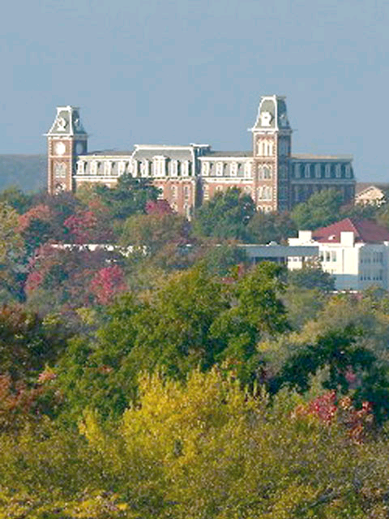
Fig1. The Old Main, University of Arkansas.

- J. Doe and R. U. Hu, Journal title 1, 246 (2007).
- A.B. Green, C.D. Black, Book title (Publisher), 135 (2006).

